INFOSYS SPRINGBOARD INTERNSHIP
Medical Inventory Management Platform
Milestone 1 – Week 1 Deliverables

Team 6
Team Members
Dharchana M A
Pentakota Pavan Prasanth
Prathima Mavarapu
Submission Date: 31 July 2026

Table of Contents
1. Project Understanding
2. Project Objectives
3. Problem Statement
4. User Roles and Permissions
5. Functional Requirements
6. Non-Functional Requirements
7. Workflow Diagram
8. System Architecture Diagram
9. Database Schema (ER Diagram)
10. UI Wireframes
11. Sample Data
12. Conclusion

1. Project Understanding

1.1 Introduction
The Medical Inventory Management Platform is a centralized web-based application that enables hospitals, clinics, and pharmacies to manage medicine inventory efficiently. The platform replaces manual registers and spreadsheets with a secure digital system that tracks medicines, suppliers, stock levels, expiry dates, and inventory transactions in real time.

1.2 Purpose
The platform aims to improve inventory accuracy, reduce medicine wastage, automate expiry and low-stock alerts, and provide dashboards and reports that support better procurement and operational decision-making.

1.3 Scope
The current scope includes role-based access control, medicine management, supplier management, inventory tracking, expiry monitoring, dashboards, and reporting for a single healthcare facility, with future scalability for multi-branch deployments.

1.4 Existing Problems in Hospitals and Pharmacies
Problem | Impact
Inconsistent stock updates | Inaccurate inventory records
Manual expiry tracking | Expired medicines may remain in stock
Guess-based reordering | Stock-outs or overstocking
Scattered supplier records | Slow procurement and audits
Lack of centralized visibility | Poor coordination across departments

2. Project Objectives

2.1 General Objective
To design and develop a secure, scalable, and user-friendly Medical Inventory Management Platform that improves inventory accuracy, operational efficiency, and accountability in hospitals and pharmacies.

2.2 Specific Objectives
Objective | Description
Inventory Automation | Automate stock inflow and outflow recording
Stock Monitoring | Provide real-time stock visibility
Expiry Tracking | Generate alerts for medicines nearing expiry
Supplier Management | Maintain supplier records and procurement history
User Authentication | Secure role-based login and access control
Report Generation | Generate inventory and supplier reports
Dashboard Analytics | Display key inventory metrics visually
Role-Based Access Control | Restrict functionality by user role

3. Problem Statement
Manual inventory management causes inaccurate stock records, medicine shortages, expired inventory, delayed procurement, and fragmented departmental records. The proposed platform solves these issues through automated stock updates, expiry monitoring, centralized supplier management, dashboards, reports, and role-based access control.

4. User Roles and Permissions
Permission | Administrator | Inventory Manager | Staff
Manage Users | Yes | No | No
Manage Medicines | Yes | Yes | No
Manage Suppliers | Yes | Yes | No
Track Inventory | Yes | Yes | View
Generate Reports | Yes | Yes | View
Dashboard Access | Yes | Yes | Limited
System Settings | Yes | No | No

5. Functional Requirements
Feature | Input | Output
Login | Email, Password | Authenticated session
User Management | User details, role | Updated user list
Medicine Management | Medicine details | Updated medicine catalog
Supplier Management | Supplier information | Supplier directory
Inventory Management | Medicine ID, quantity | Updated stock levels
Expiry Alerts | Expiry date | Alert notifications
Reports | Date range, report type | Downloadable PDF/table
Dashboard | Live inventory data | Charts and summary cards

6. Non-Functional Requirements
Requirement | Description
Security | Authentication, authorization, encrypted passwords
Performance | Fast search and stock updates
Reliability | Consistent operation with minimal failures
Availability | Accessible during operating hours
Maintainability | Modular and extensible codebase
Scalability | Supports growth in users and transactions
Usability | Easy for non-technical staff
Backup & Recovery | Periodic backups and data restoration

7. Workflow Diagram
The workflow below illustrates the complete user interaction flow from authentication to reporting and logout.
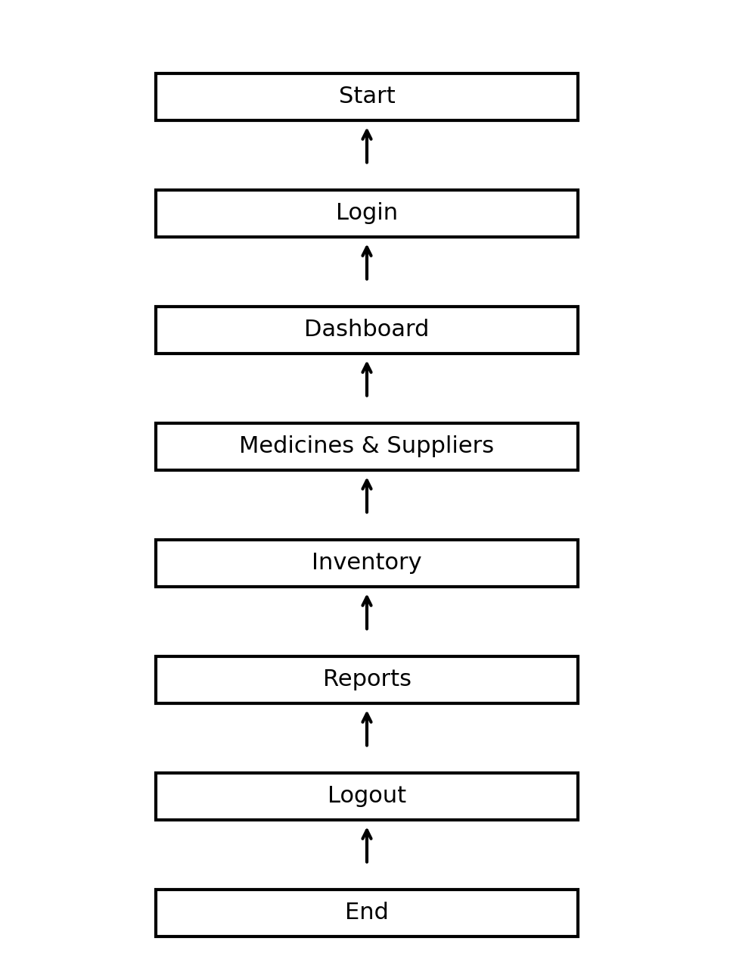
Figure 1: Workflow Diagram

8. System Architecture Diagram
The platform follows a layered architecture separating presentation, business logic, API communication, and persistent storage.
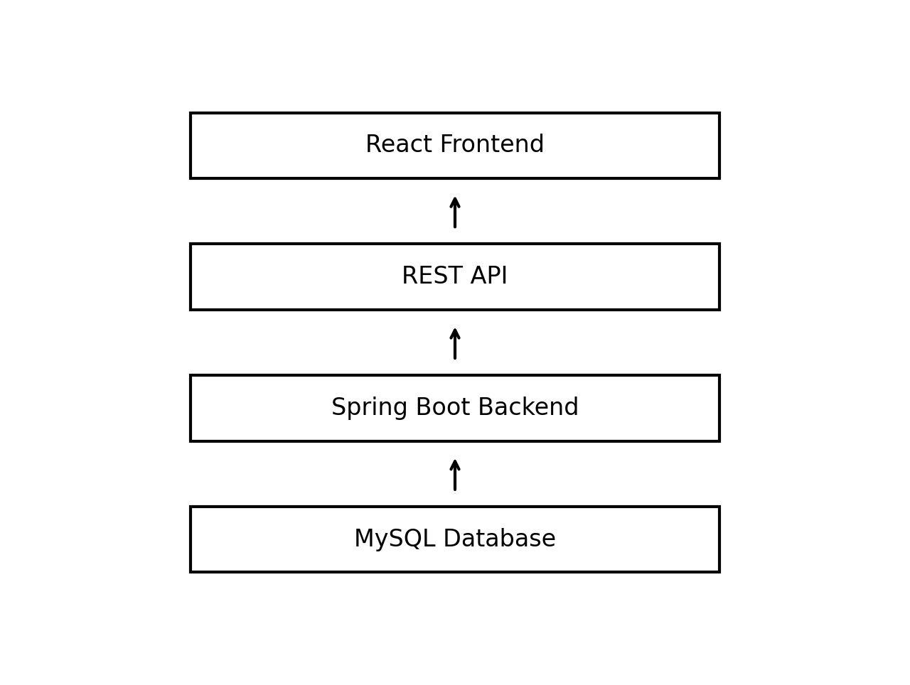
Figure 2: Layered System Architecture

9. Database Schema (ER Diagram)
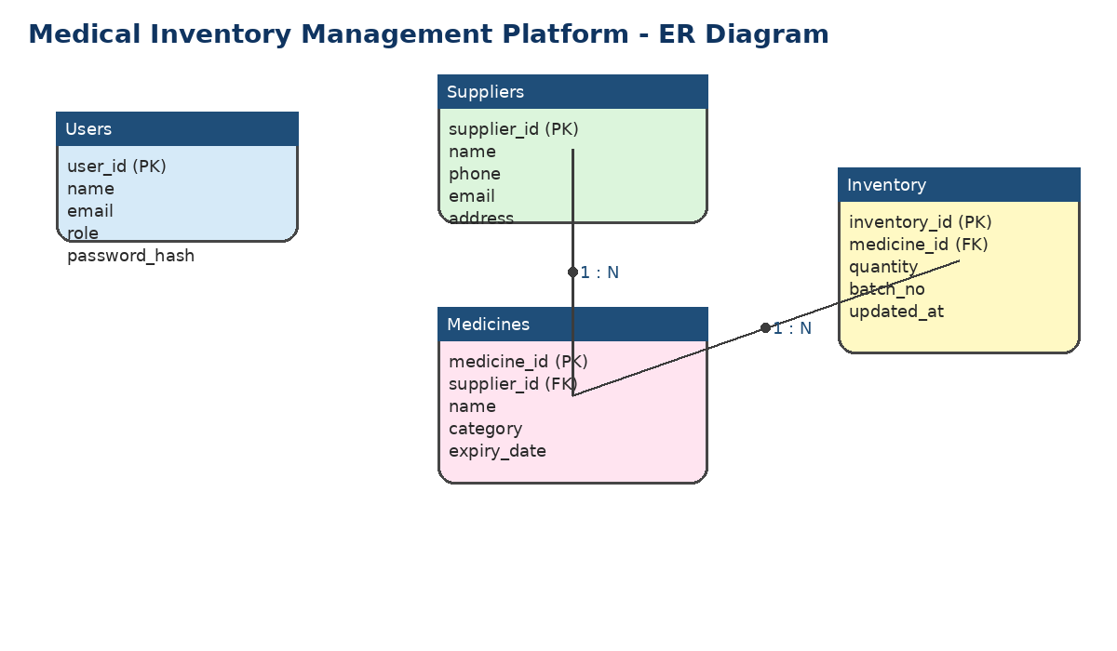
The core entities are Users, Suppliers, Medicines, and Inventory. Medicines reference suppliers, and inventory records reference medicines.
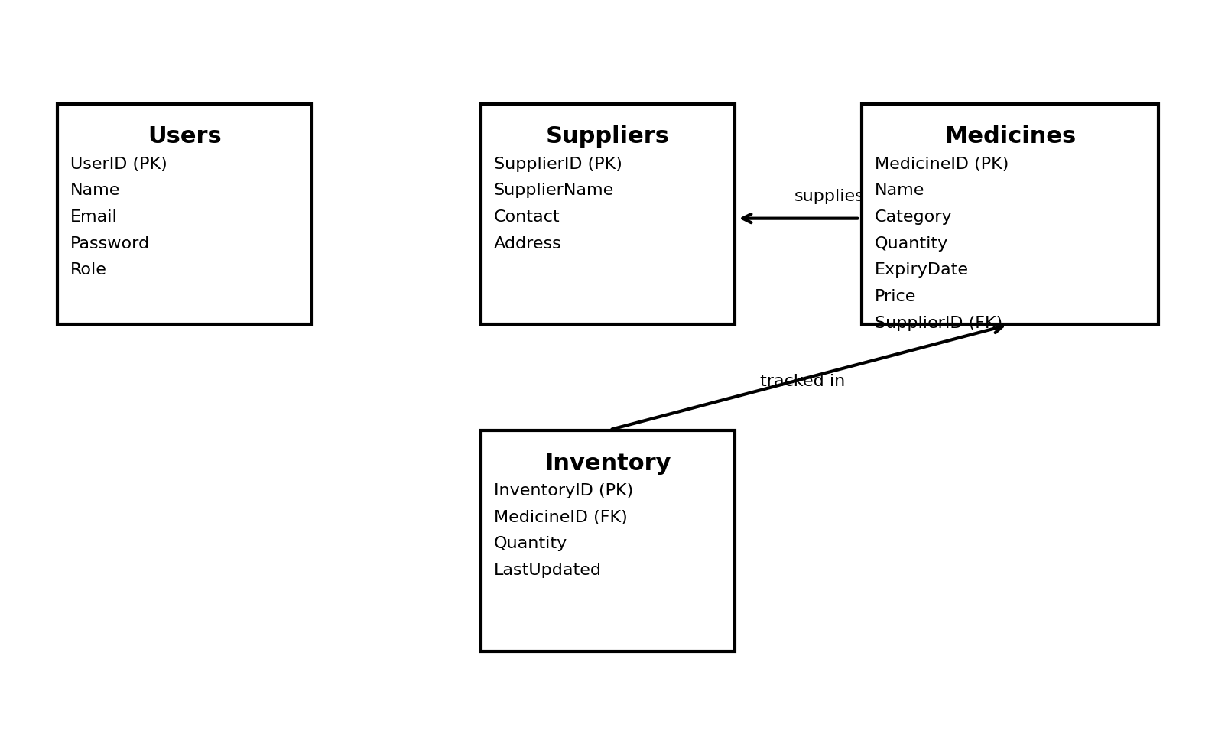
Figure 3: Entity-Relationship Diagram

10. UI Wireframes
Low-fidelity wireframes are provided below to illustrate the initial user interface layout.
Login Page
[ Logo ]
Email: __________________
Password: _______________
[ Login Button ]

Dashboard
Cards: Total Medicines | Low Stock | Expired Medicines | Suppliers
Sidebar: Dashboard | Medicines | Suppliers | Inventory | Reports

Medicine Management
[ Search ] [ Add Medicine ]
Medicine Table: Name | Category | Qty | Expiry | Actions

Supplier Page
Supplier List
[ Add Supplier ]
Contact Information Panel

Reports Page
Charts: Consumption Trend | Stock Distribution
Inventory Summary
[ Download Report Button ]

11. Sample Data
The following sample datasets illustrate the structure and expected content of the core database entities identified in the ER diagram: Users, Suppliers, Medicines, and Inventory transactions.

11.1 Sample Users
User ID | Name | Email | Role
U001 | Ananya Rao | ananya.rao@medicare.com | Administrator
U002 | Vikram Sen | vikram.sen@medicare.com | Inventory Manager
U003 | Sara Thomas | sara.thomas@medicare.com | Staff
U004 | Rahul Nair | rahul.nair@medicare.com | Inventory Manager

11.2 Sample Suppliers
Supplier ID | Supplier Name | Contact Number | Email | Address
SUP001 | MediSupply Corp | +91 9876543210 | contact@medisupply.com | Hyderabad, TS
SUP002 | HealthCare Distributors | +91 9123456780 | info@hcdist.com | Vijayawada, AP
SUP003 | PharmaLink Traders | +91 9988776655 | sales@pharmalink.com | Chennai, TN
SUP004 | WellCare Pharma | +91 9012345678 | support@wellcarepharma.com | Bengaluru, KA

11.3 Sample Medicines
Medicine ID | Medicine Name | Category | Quantity | Expiry Date | Supplier ID
MED001 | Paracetamol 500mg | Analgesic | 1200 | 12-2027 | SUP001
MED002 | Amoxicillin 250mg | Antibiotic | 350 | 08-2026 | SUP002
MED003 | Cetirizine 10mg | Antihistamine | 600 | 03-2027 | SUP003
MED004 | Insulin Glargine | Hormone | 80 | 11-2026 | SUP004
MED005 | Metformin 500mg | Antidiabetic | 900 | 06-2027 | SUP001

11.4 Sample Inventory Transactions
Transaction ID | Medicine ID | Transaction Type | Quantity | Date
TXN001 | MED001 | Stock In | 500 | 01-07-2026
TXN002 | MED002 | Stock Out | 50 | 05-07-2026
TXN003 | MED003 | Stock In | 300 | 10-07-2026
TXN004 | MED004 | Stock Out | 10 | 15-07-2026
TXN005 | MED005 | Stock In | 400 | 20-07-2026

11.5 Sample Customer Medicine Transactions
The table below presents a sample of customer-facing medicine sale transactions, illustrating the structure of the Customer_Medicine_Transactions dataset used by the point-of-sale and billing module.
Transaction_ID | Customer_Name | Phone_Number | Email_Address | Medicine_Name | Cost_of_Medicine (₹)
TXN001 | Ananya Sharma | +91 9845123456 | ananya.sharma@gmail.com | Paracetamol 500 mg | ₹45.00
TXN002 | Rajesh Kumar | +91 9876501234 | rajesh.kumar@yahoo.com | Amoxicillin 250 mg | ₹120.50
TXN003 | Priya Reddy | +91 9123456789 | priya.reddy@outlook.com | Dolo 650 mg | ₹35.00
TXN004 | Suresh Iyer | +91 9988776655 | suresh.iyer@gmail.com | Cetirizine 10 mg | ₹60.25
TXN005 | Meena Nair | +91 9012345678 | meena.nair@rediffmail.com | Azithromycin 500 mg | ₹210.00
TXN006 | Arjun Patel | +91 9765432109 | arjun.patel@gmail.com | Metformin 500 mg | ₹55.75
TXN007 | Kavya Menon | +91 9654321087 | kavya.menon@yahoo.com | Ibuprofen 400 mg | ₹40.00
TXN008 | Vivek Singh | +91 9543210976 | vivek.singh@gmail.com | Pantoprazole 40 mg | ₹95.30
TXN009 | Deepika Rao | +91 9432109865 | deepika.rao@outlook.com | Ranitidine 150 mg | ₹85.60
TXN010 | Manoj Verma | +91 9321098754 | manoj.verma@gmail.com | Vitamin B-Complex 500 mg | ₹150.00

12. Conclusion
The Medical Inventory Management Platform provides a robust foundation for digitizing medicine inventory operations in healthcare institutions. Through automation, role-based security, centralized data management, dashboards, and reporting, the system reduces wastage, prevents stock shortages, improves procurement planning, and supports better patient care outcomes.

